<https://www.cloudflare.com/learning/cdn/glossary/reverse-proxy/>

Regular or Forward Proxy: PROXIES CLIENT REQUESTS TO INTERNET

Is placed before the client machines.

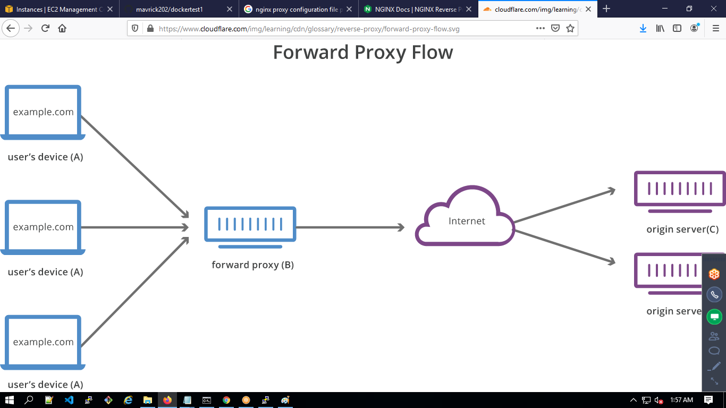

Reverse Proxy: Placed before Servers, the requests from users are intercepted by Proxy and sent to backend servers.

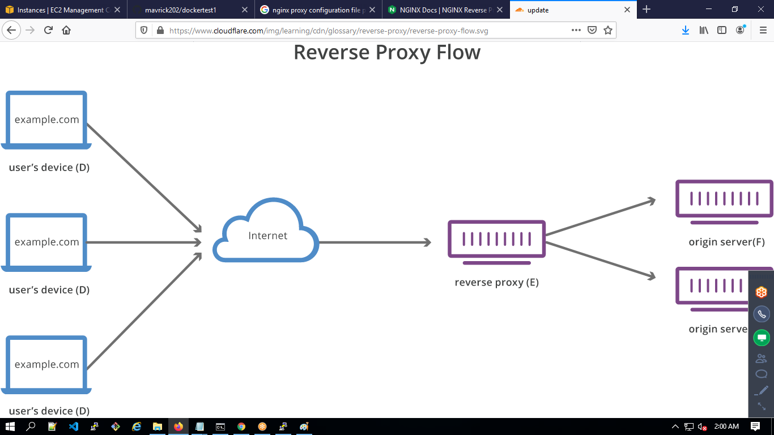

server {

listen 80;

listen [::]:80;

server_name localhost;

#charset koi8-r;

#access_log /var/log/nginx/host.access.log main;

location / {

#root /usr/share/nginx/html;

#index index.html index.htm;

proxy_pass http://<GiveDockerServiceNameHere>;

}

#error_page 404 /404.html;

# redirect server error pages to the static page /50x.html

#

error_page 500 502 503 504 /50x.html;

location = /50x.html {

root /usr/share/nginx/html;

}

# proxy the PHP scripts to Apache listening on 127.0.0.1:80

#

#location ~ \.php$ {

# proxy_pass http://127.0.0.1;

#}

# pass the PHP scripts to FastCGI server listening on 127.0.0.1:9000

#

#location ~ \.php$ {

# root html;

# fastcgi_pass 127.0.0.1:9000;

# fastcgi_index index.php;

# fastcgi_param SCRIPT_FILENAME /scripts$fastcgi_script_name;

# include fastcgi_params;

#}

# deny access to .htaccess files, if Apache's document root

# concurs with nginx's one

#

#location ~ /\.ht {

# deny all;

#}

}

docker service create --name devopsclass --replicas 1 --network testing_nginx_proxy sreeharshav/testcontainer:v1

docker service create --name devopsproxy --config src=devopsclass,target=/etc/nginx/conf.d/default.conf --publish 8500:80 --network testing_nginx_proxy sreeharshav/nginxproxy:v1

NOTE:Make sure the docker service name and the line http://<GiveDockerServiceNameHere> must be same ,otherwise proxy container/service fail.